Faculty of Computing



Database Systems Lab Manual # 10

Sitara Rehman

Sap ID:66454

**TASK:1**

Retrieve all columns from the "Users" table.

**SOLUTION:**

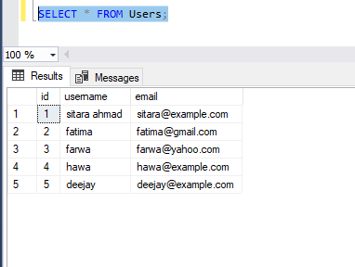

**TASK:2**

Retrieve all users whose usernames start with the letter 'A'.

**SOLUTION:**

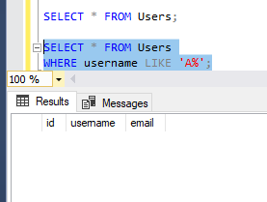

**TASK:3**

Retrieve all products priced between $10 and $50 and whose names contain 'phone' or 'tablet'.

**SOLUTION:**

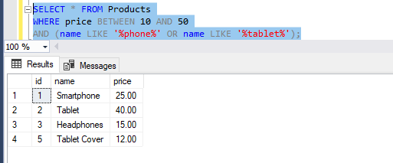

**TASK:4**

Retrieve all orders placed by user_id 3 ordered by their creation date in descending order.

**SOLUTION:**

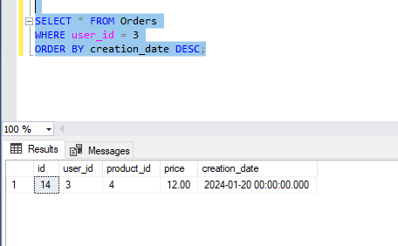

**TASK:5**

Find the minimum and maximum price of products in the "Products" table.

**SOLUTION:**

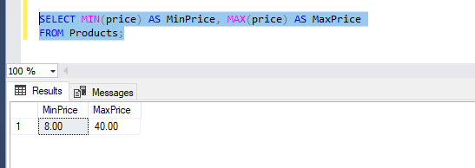

**TASK:6**

Retrieve the first 10 orders placed.

**SOLUTION:**

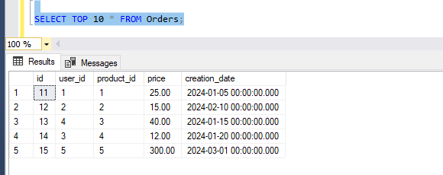

**TASK:7**

Count the total number of orders placed, calculate the average price of products, and sum up the total price of all orders.

**SOLUTION:**

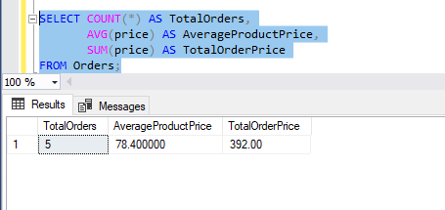

**TASK:8**

Retrieve all users whose emails end with '@example.com'.

**SOLUTION:**

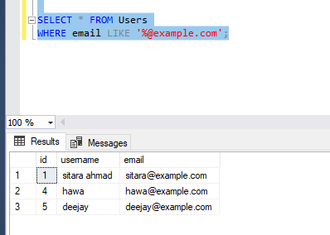

**TASK:9**

Retrieve all products with IDs 1, 5, and 9.

**SOLUTION:**

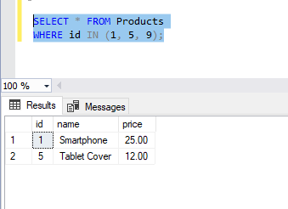

**TASK:10**

Retrieve all orders placed between January 1, 2024, and February 1, 2024.

**SOLUTION:**

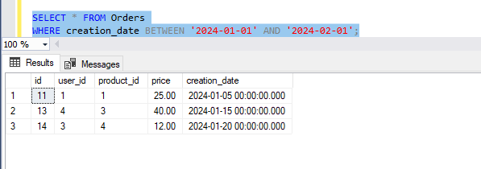

**TASK:11**

Retrieve the total price of orders, aliased as "order_total".

**SOLUTION:**

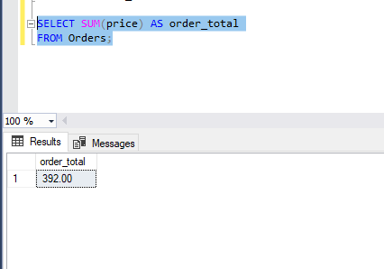

**TASK:12**

Retrieve unique product names from the "Products" table.

**SOLUTION:**

